**C PROGRAMMING ASSIGNMENT:**

**17**

DATE: 06.01.22

SUBMITTED BY: -

NAME: MUKTESH MISHRA

BRANCH: CSE

SECTION: B22

ROLL NO.: 21052258

**1.WAP to find sum of two integers using pointers**

***Code:***

#include<stdio.h>

*int* main(*int* *argc*, *char* const \**argv*[])

{

*int* a, b, *p, *q, sum;

   printf("Enter two integers to add\n");

   scanf("%d%d", &a, &b);

   p = &a;

   q = &b;

   sum = *p + *q;

   printf("Sum of the numbers = %d\n", sum);

    return 0;

}

***Output:***

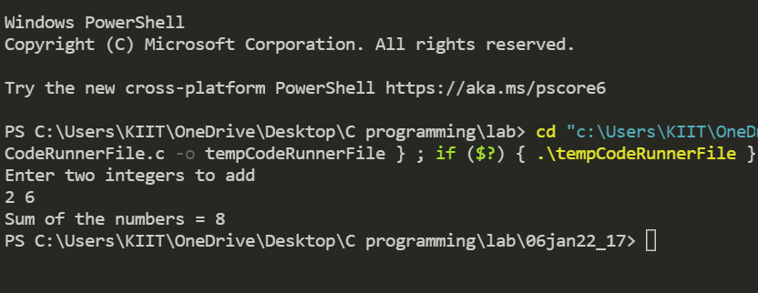

1. **WAP to swap two numbers using pointers**

***Code:***

#include <stdio.h>

*int* main()

{

*int* x, y, *a, *b, temp;

    printf("Enter the value of x and y\n");

    scanf("%d%d", &x, &y);

    printf("Before Swapping\nx = %d\ny = %d\n", x, y);

    a = &x;

    b = &y;

    temp = *b;

    *b = *a;

    *a = temp;

    printf("After Swapping\nx = %d\ny = %d\n", x, y);

    return 0;

}

***Output:***

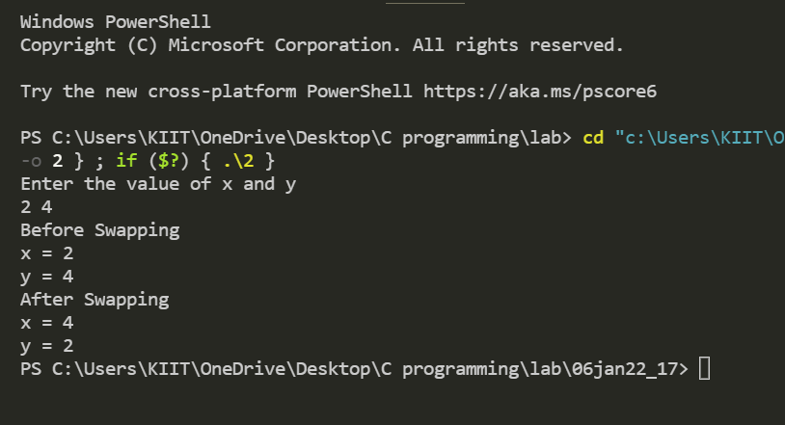

1. **WAP to find greater of 2 nos**

***Code:***

#include <stdio.h>

*void* main()

{

*int* x, y, *large, *a, *b;

    printf("Enter the value of x and y :");

    scanf("%d%d", &x, &y);

    a = &x;

   b = &y;

    if (*a > *b)

        large = a;

    else

        large = b;

    printf("The greater number is : %d", *large);

}

***Output:***

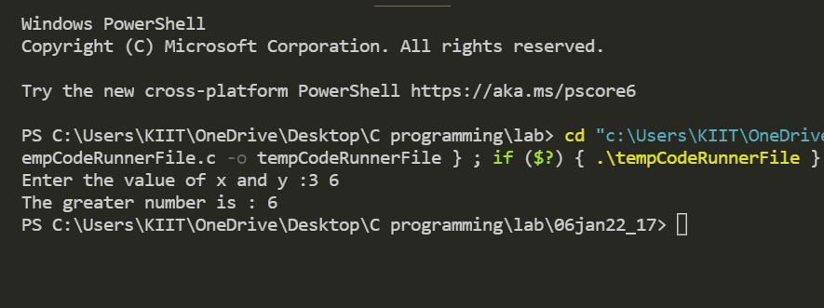

1. **WAP to find middle integer of an array of five integers using pointers**

***Code:***

#include <stdio.h>

*int* main()

{

*int* data[5], *a, t, i, j;

    printf("Enter elements: \n");

    for (i = 0; i < 5; ++i)

    {

        printf("Enter element at index %d\n", i);

        scanf("%d", data + i);

    }

    for (i = 0; i < 5; ++i)

    {

        printf("%d\t", data[i]);

    }

    for (i = 0; i < 5; ++i)

    {

        for (j = i + 1; j < 5; ++j)

        {

            if (data[i] > data[j])

            {

                t = data[i];

                data[i] = data[j];

                data[j] = t;

            }

        }

    }

    printf("\nAscending order:\n");

    for (*int* i = 0; i < 5; ++i)

    {

        printf("%d\t", data[i]);

    }

    a = data;

    printf("\n  %d\n", *(a + 2));

    return 0;

}

***Output:***

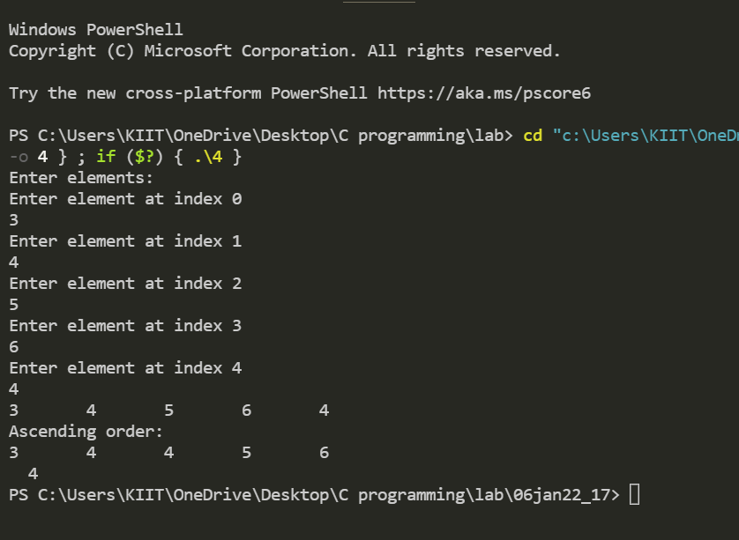

1. **WAP to add elements in an array using pointers**

***Code:***

#include <stdio.h>

*int* main()

{

*int* i, *ptr, sum = 0, arr[5] = {2, 4, 6, 8, 0};

    ptr = arr;

    for (i = 0; i < 5; ++i)

    {

        sum = sum + (*ptr + i);

    }

    printf("sum=%d",sum);

    return 0;

}

***Output:***

